<!DOCTYPE html>
<html>
<head>
<title>Responsive Layout</title>
<meta name="viewport" content="width=device-width, initial-scale=1.0">

<style>
* {
box-sizing: border-box;
}

body {
margin: 0;
font-family: Arial, sans-serif;
}

header {
background: steelblue;
color: white;
text-align: center;
padding: 20px;
}

nav {
display: flex;
justify-content: center;
gap: 20px;
background: #333;
padding: 15px;
flex-wrap: wrap;
}

nav a {
color: white;
text-decoration: none;
}

.container {
display: grid;
grid-template-columns: repeat(3, 1fr);
gap: 15px;
padding: 20px;
}

.box {
background: lightblue;
padding: 30px;
text-align: center;
border-radius: 8px;
}

@media (max-width: 768px) {
.container {
grid-template-columns: repeat(2, 1fr);
}
}

@media (max-width: 480px) {
.container {
grid-template-columns: 1fr;
}
}
</style>
</head>

<body>
<header>
<h1>Responsive Website</h1>
</header>

<nav>
<a href="#">Home</a>
<a href="#">About</a>
<a href="#">Services</a>
<a href="#">Contact</a>
</nav>

<div class="container">
<div class="box">Section 1</div>
<div class="box">Section 2</div>
<div class="box">Section 3</div>
</div>
</body>
</html>
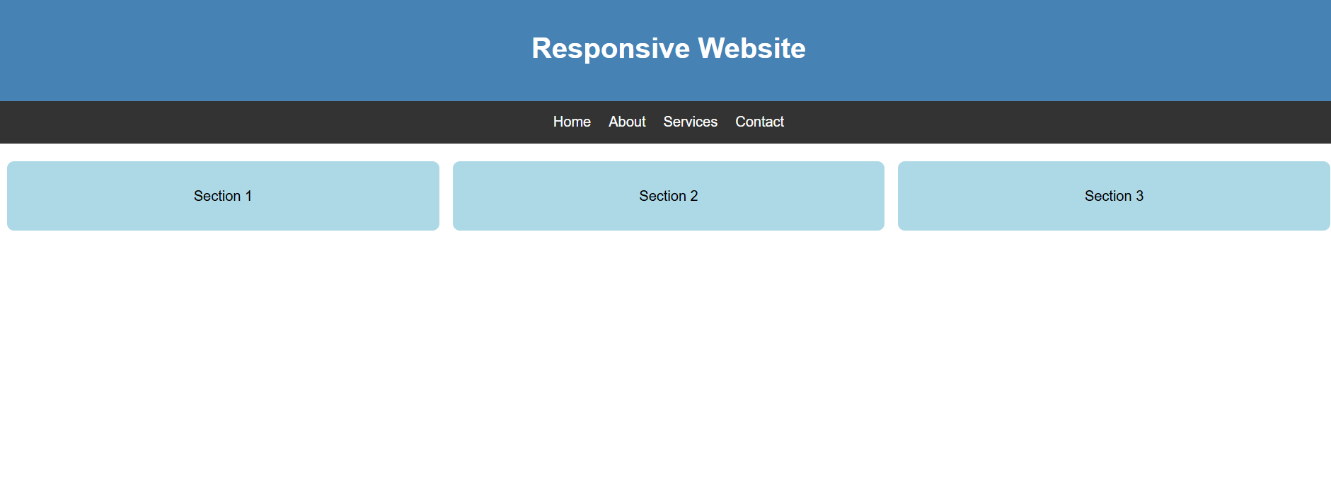

<!DOCTYPE html>
<html>
<head>
<title>Form Validation</title>

<style>
body {
font-family: Arial, sans-serif;
background: #f0f0f0;
padding: 20px;
}

form {
background: white;
max-width: 350px;
margin: auto;
padding: 20px;
border-radius: 8px;
}

input {
width: 100%;
padding: 10px;
margin: 8px 0;
box-sizing: border-box;
}

button {
width: 100%;
padding: 10px;
background: steelblue;
color: white;
border: none;
cursor: pointer;
}

.error {
color: red;
font-size: 14px;
}
</style>
</head>

<body>
<form id="myForm" novalidate>
<h2>Registration Form</h2>

<label>Name:</label>
<input type="text" id="name" placeholder="Enter name">
<div id="nameError" class="error"></div>

<label>Email:</label>
<input type="text" id="email" placeholder="Enter email">
<div id="emailError" class="error"></div>

<label>Phone Number:</label>
<input type="text" id="phone" placeholder="10-digit number">
<div id="phoneError" class="error"></div>

<button type="submit">Register</button>
<p id="result"></p>
</form>

<script>
document.getElementById("myForm")
.addEventListener("submit", function(event) {
event.preventDefault();

let name = document.getElementById("name").value.trim();
let email = document.getElementById("email").value.trim();
let phone = document.getElementById("phone").value.trim();

let valid = true;

document.getElementById("nameError").innerHTML = "";
document.getElementById("emailError").innerHTML = "";
document.getElementById("phoneError").innerHTML = "";
document.getElementById("result").innerHTML = "";

if (name.length < 2) {
document.getElementById("nameError")
.innerHTML = "Enter a valid name.";
valid = false;
}

let emailPattern = /^[^\s@]+@[^\s@]+\.[^\s@]+$/;

if (!emailPattern.test(email)) {
document.getElementById("emailError")
.innerHTML = "Enter a valid email.";
valid = false;
}

let phonePattern = /^[0-9]{10}$/;

if (!phonePattern.test(phone)) {
document.getElementById("phoneError")
.innerHTML = "Enter exactly 10 digits.";
valid = false;
}

if (valid) {
document.getElementById("result").innerHTML =
"Registration successful!";
document.getElementById("result").style.color = "green";
} else {
document.getElementById("result").innerHTML =
"Please correct the errors.";
document.getElementById("result").style.color = "red";
}
});
</script>
</body>
</html>
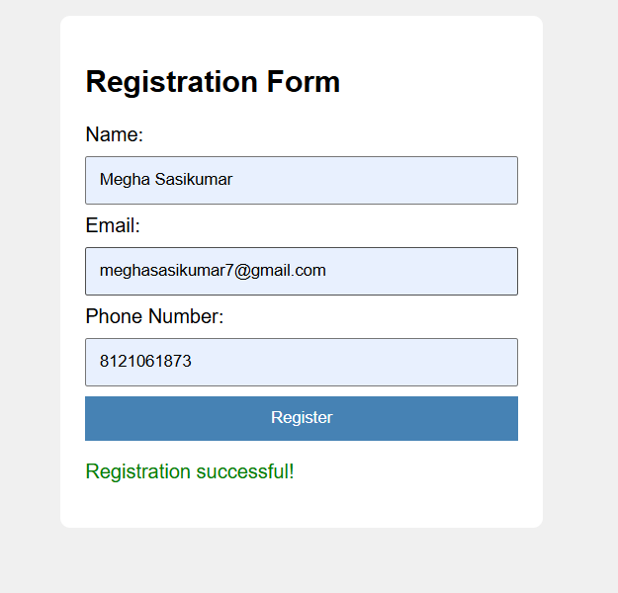

<!DOCTYPE html>
<html>
<head>
<title>CSS Layout Debugging</title>
<meta name="viewport" content="width=device-width, initial-scale=1.0">

<style>
* {
box-sizing: border-box;
}

body {
margin: 0;
font-family: Arial, sans-serif;
}

header {
background: darkslateblue;
color: white;
padding: 20px;
text-align: center;
}

.container {
display: flex;
gap: 20px;
padding: 20px;
max-width: 1000px;
margin: auto;
}

.sidebar {
flex: 0 0 250px;
background: lightgray;
padding: 20px;
}

.content {
flex: 1;
min-width: 0;
background: lightblue;
padding: 20px;
}

footer {
background: #333;
color: white;
text-align: center;
padding: 15px;
}

@media (max-width: 600px) {
.container {
flex-direction: column;
}

.sidebar,
.content {
width: 100%;
flex-basis: auto;
}
}
</style>
</head>

<body>
<header>
<h1>CSS Layout Debugging</h1>
</header>

<div class="container">
<div class="sidebar">
<h2>Sidebar</h2>
<p>Sidebar information goes here.</p>
</div>

<div class="content">
<h2>Main Content</h2>
<p>
Flexbox is used to align the sidebar and content.
Media queries prevent overlapping on small screens.
</p>
</div>
</div>

<footer>
Web Development Lab
</footer>
</body>
</html>
